Reactant | MCMv3.2 designationª | Products | Absorption Cross-section (σ)§ | Quantum Yield (φ)§ | Comments
Carbonyls
HCHO | (J₁₁)  (J₁₂) | → H + HCO  → H₂ + CO | Meller and Moortgat (2000) link  IUPAC recommended | (J₁₁) Smith et al. (2002) link  (J₁₂) Moortgat et al. (1983) link  IUPAC recommended | - Temperature dependent CS.  - (J₁₂) QYs are p and T dependent > 330 nm.
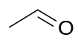  CH3CHO | (J₁₃) | → CH₃ + HCO | Martinez et al. (1992) link  IUPAC recommended | Meyrahn et al. (1982)  IUPAC recommended | - Only the radical channel (J₁₃) is important > 290 nm.
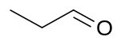  C2H5CHO | (J₁₄) | → C₂H₅ + HCO | Martinez et al. (1992) link  IUPAC recommended | Chen and Zhu (2001) link  IUPAC datasheet | - (J₁₄) p dependent QYs calculation available here.  - IUPAC discusses QY but cannot recommend values.
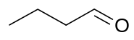  C3H7CHO | (J₁₅)^{b}  (J₁₆) | → n-C₃H₇ + HCO  → C₂H₄ + CH₃CHO | Martinez et al. (1992) link  IUPAC recommended | (J₁₅) Tadic et al. (2001) link  (J₁₆) Tadic et al. (2001) link  IUPAC recommended | - QY (J₁₅) 0.21 (290 to 380 nm)  - QY (J₁₆) 0.10 (290 to 380 nm)
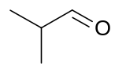  IPRCHO | (J₁₇)^{b} | → n-C₄H₉ + HCO | Martinez et al. (1992) link | Chen et al. (2002) link
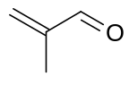  MACR | (J₁₈)^{b}  (J₁₉)^{b} | → CH₂=CCH₃ + HCO  → CH₂=C(CH₃)CO + H | Gierczak et al. (1997) link  IUPAC recommended | Average from:  Carter (2000)  Moortgat et al. (2000)  Pinho et al. (2005) link  IUPAC datasheet | - QY (J₁₈) 1.95E-3  - QY (J₁₉) 1.95E-3  - See Pinho et al. (2005) link for details
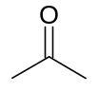  CH3COCH3 | (J₂₁) | → CH₃CO + CH₃ | Gierczak et al. (1998) link  IUPAC recommended | Blitz et al. (2004) link  IUPAC recommended | - T dependent CS defined.  - 298 K CS available here (calculation here).  - 1 bar and 298 K QY defined.  - T and p dependent QY calculation available here.  - Only channel (J₂₁) currently defined in MCMv3.2.

Reactant | Products | Absorption Cross-section (σ) | Quantum Yield  (φ)
Ketones

 | → CH₃CO + CH₃ | Gierczak et al. (1998) | Blitz et al. (2004)
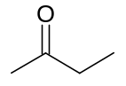 | → CH₃CO + C₂H₅ | Martinez et al. (1992) | Pinho et al. (2005)
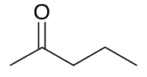 | → CH₃CO + C₃H₇  → Norrish? | Martinez et al. (1992) | Raber and Moortgat (1996)  (Pinho et al. (2005))
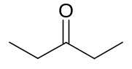 | → CH₃CH₂C(.)O + C₂H₅ | Martinez et al. (1992) | Raber and Moortgat (1996)  (Pinho et al. (2005))
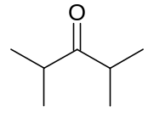 | → (CH₃)₂CHC(.)O +  CH₃C(.)CH₃ | Yujing and Mellouki (2000) | Raber and Moortgat (1996)  (Pinho et al. (2005))
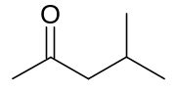 | → CH₃CO + i-C₄H₉  → CH₃C(O)CH₃ +  (CH₃)₂C=CH₂ | Yujing and Mellouki (2000) | Raber and Moortgat (1996)  (Pinho et al. (2005))
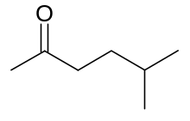 | → CH₃CO + i-C₅H₁₁  → CH₃C(O)CH₃ +  (CH₃)₂CHCH=CH₂ | Yujing and Mellouki (2000) | Raber and Moortgat (1996)  (Pinho et al. (2005))
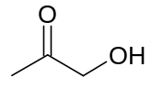 | → CH₃CO + CH₂OH  → HOCH₂C(.)O + CH₃ | Orlando et al. (1992) | Orlando et al. (2003)
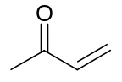 | → CH₃CO + CH₂=CH  → CH₃CH=CH₂ + CO  → CH₂=CHC(.)O + CH₃ | Gierczak et al. (1997)) | Gierczak et al. (1997)

Reactant | Products | Absorption Cross-section (σ) | Quantum Yield  (φ)
α-dicarbonyls

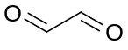 | → 2CO + H₂  → HCO + HCO  → HCHO + CO | Volkamer et al. (2005) | Moortgat et al. (2000)
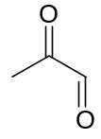 | → CH₃CO + HCO | Atkinson et al. (2005)  IUPAC 05 | Koch and Moortgat (1997)  (Chen et al. (2000))
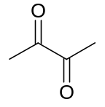 | → CH₃CO + CH₃CO | Horowitz et al. (2001) | Plum et al. (1983)
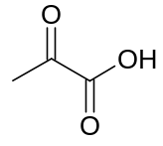 | → CH₃CO + HOCO  → CH₃CHO + CO₂  → CH₃C(O)OH + CO  → CH₃CO + CO + OH | Horowitz et al. (2001) | Moortgat et al. (2000)

Reactant | Products | Absorption Cross-section (σ) | Quantum Yield  (φ)
Nitrates

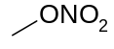 | → CH₃O + NO₂ | Atkinson et al. (2005)  IUPAC 05 | Atkinson et al. (2005)  IUPAC 05
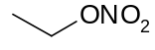 | → C₂H₅O + NO₂ | Atkinson et al. (2005)  IUPAC 05 | Atkinson et al. (2005)  IUPAC 05
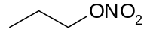 | → C₃H₇O + NO₂ | Atkinson et al. (2005)  IUPAC 05 | Atkinson et al. (2005)  IUPAC 05
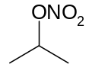 | → CH₃C(O.)CH₃ + NO₂ | Atkinson et al. (2005)  IUPAC 05 | Atkinson et al. (2005)  IUPAC 05
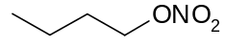 | → n-C₄H₉O + NO₂ | MPI-Mainz Spectral Atlas average | φ = 1
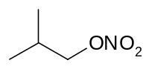 | → i-C₄H₉O + NO₂ | Clemitshaw et al. (1998) | φ = 1
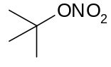 | → t-C₄H₉O + NO₂ | Roberts and Fajer (1989) | φ = 1
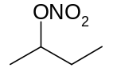 | → CH₃C(O.)C₂H₅+ NO₂ | Atkinson et al. (2005)  IUPAC 05 | Atkinson et al. (2005)  IUPAC 05
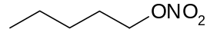 | → C₅H₁₁O + NO₂ | Clemitshaw et al. (1998)  Zhu and Kellis (1997) | φ = 1
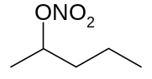 | → CH₃C(O.)C₃H₇+ NO₂ | Roberts and Fajer (1989) | φ = 1
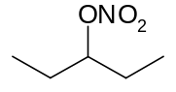 | → C₂H₅C(O.)C₂H₅+ NO₂ | Roberts and Fajer (1989) | φ = 1
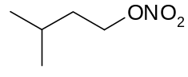 | → i-C₅H₁₁O + NO₂ | Turberg et al. (1990) | φ = 1
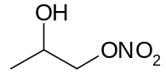 | → CH₃C(OH)CH₂O+ NO₂ | Roberts and Fajer (1989) | φ = 1

Reactant | Products | Absorption Cross-section (σ) | Quantum Yield  (φ)
Di-nitrates

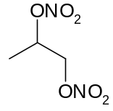 | → CH₃CH(O.)CH₂(ONO₂)  + NO₂  → CH₃CH(ONO₂)CH₂(O.)  + NO₂ | Barnes et al. (1993) | φ = 1
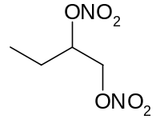 | → C₂H₅CH(O.)CH₂(ONO₂)  + NO₂  → C₂H₅CH(ONO₂)CH₂(O.)  + NO₂ | Barnes et al. (1993) | φ = 1
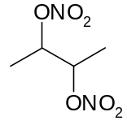 | → CH₃CH(O.)CH(ONO₂)CH₃  + NO₂ | Barnes et al. (1993) | φ = 1
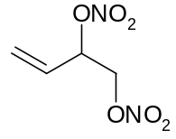 | → CH₂=CHCH(O.)CH₂(ONO₂)  + NO₂  → CH₂=CHCH(ONO₂)CH₂(O.)  + NO₂ | Barnes et al. (1993) | φ = 1
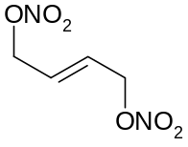 | → CH₂(O.)CH=CHCH₂(ONO₂)  + NO₂  → CH₂(ONO₂)CH=CHCH₂(O.)  + NO₂ | Barnes et al. (1993) | φ = 1

Reactant | Products | Absorption Cross-section (σ) | Quantum Yield  (φ)
Nitro-ketones

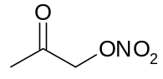 | → CH₃C(O)CH₂(O.) + NO₂  → CH₃CO + HCHO + NO₂ | Barnes et al. (1993) | φ = 1
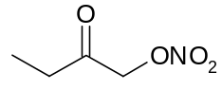 | → C₂H₅C(O)CH₂(O.) + NO₂ | Barnes et al. (1993) | φ = 1
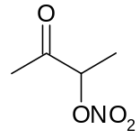 | → CH₃CH(O.)C(O)CH₃  + NO₂ | Barnes et al. (1993) | φ = 1
Organic Peroxides

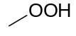 | → CH₃O + OH | Vaghjiani and Ravishankara (1989) | φ = 1
Peroxy nitrates

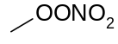 | → CH₃O₂ + NO₂  → CH₃O + NO₃ | Atkinson et al. (2005)  IUPAC 05 | Atkinson et al. (2005)  IUPAC 05
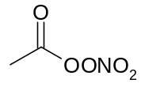 | → CH₃C(O)O(O.) + NO₂ | Talukdar et al. (1995) | φ = 1
Unsaturated carbonyls

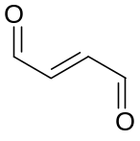 | 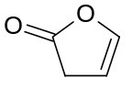 | Bierbach et al. (1994) | Bierbach et al. (1994)
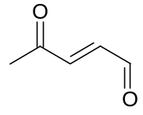 | 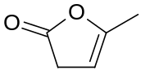 | Bierbach et al. (1994) | Bierbach et al. (1994)
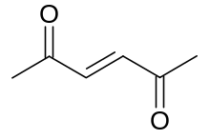 | 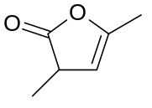 | Bierbach et al. (1994) | Bierbach et al. (1994)

